CMPG 325 NETWORKING PROJECT
PART 1: Network Topologies Design & Simulation
- 5 Topologies: Bus, Mesh, Star, Ring, Extended Star.
- 1 Hybrid topology integrating elements of the above. Configured with IPv4 & IPv6, VLAN segmentation, at least one server (HTTP/DNS/DHCP), and basic security.

NAME:MERLICIA GUDANI MUNYAI

RING TOPOLOGY
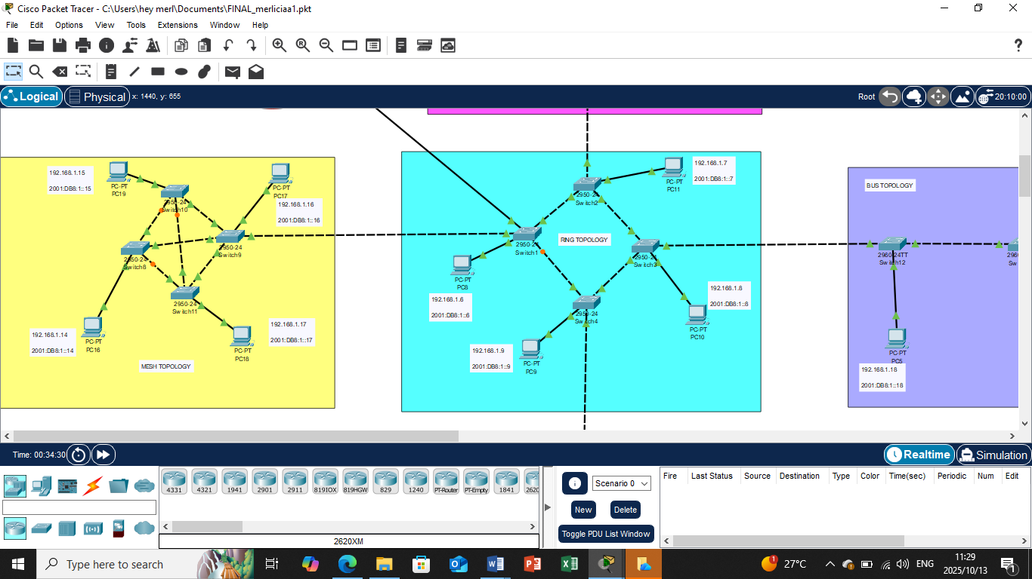

STAR TOPOLOGY
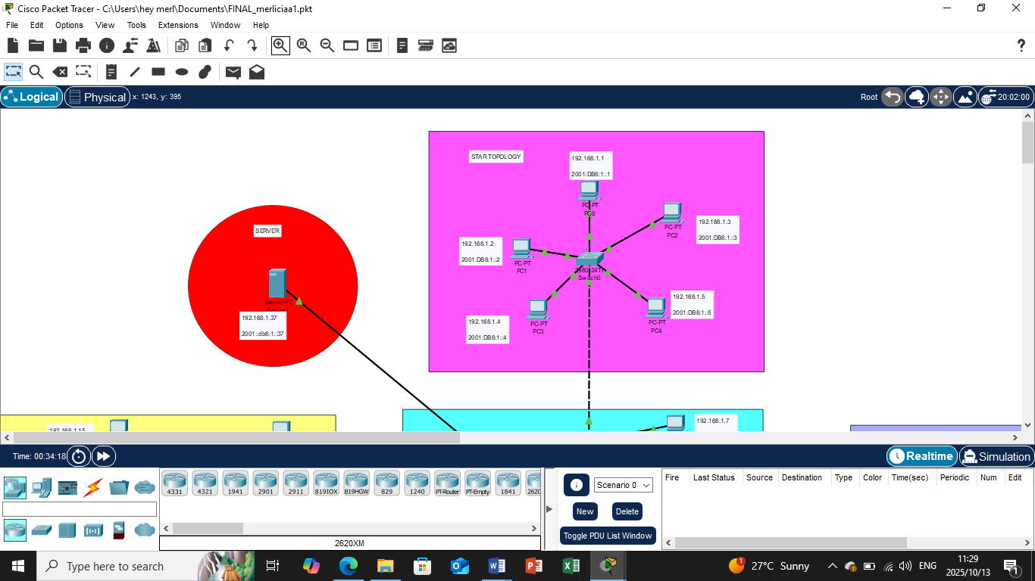

MESH TOPOLOGY
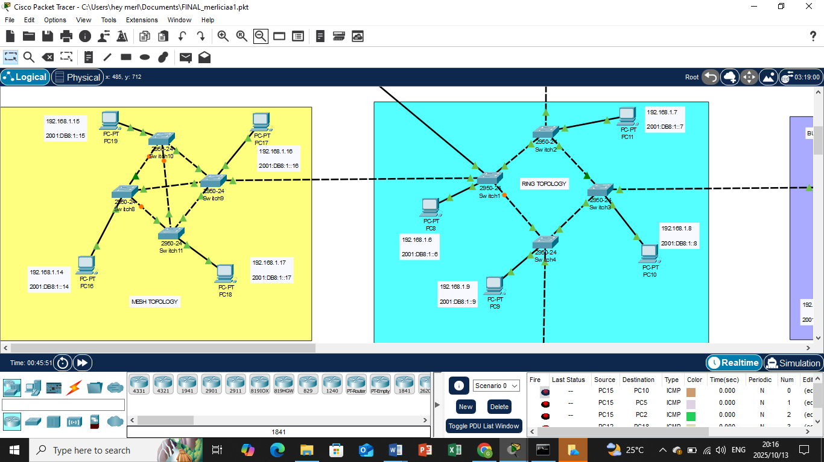

EXTENDED STAR TOPOLOGY

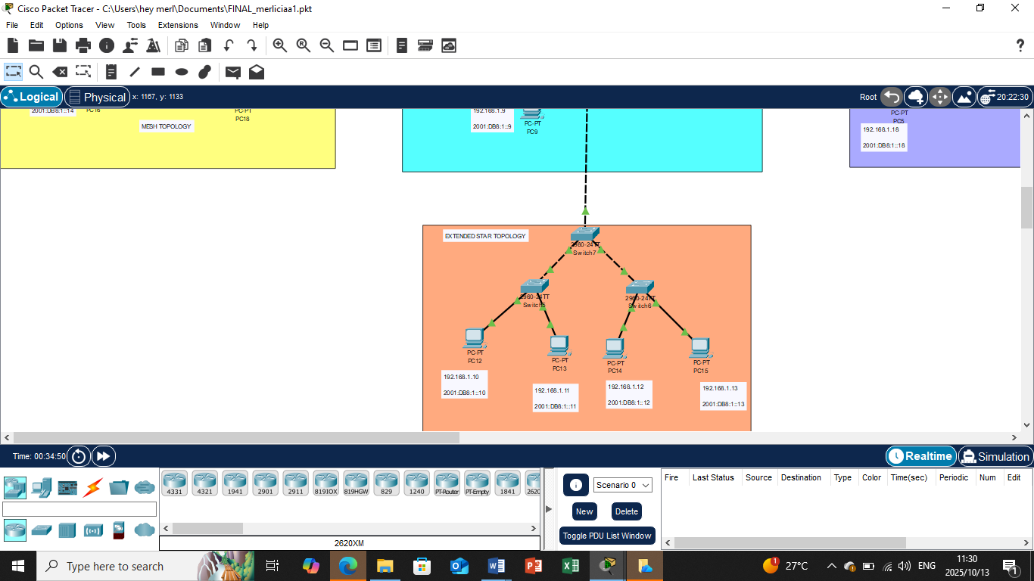

BUS TOPOLOGY
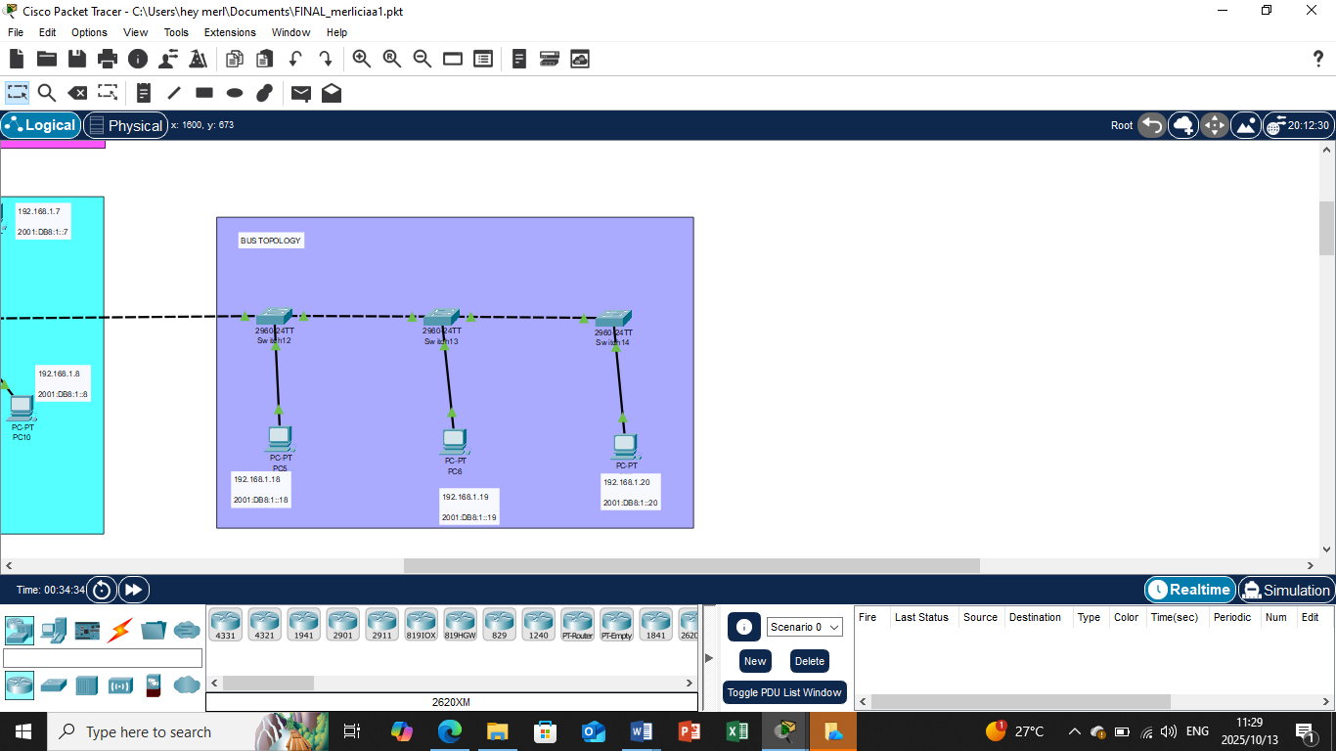

HYBRID TOPOLOGY
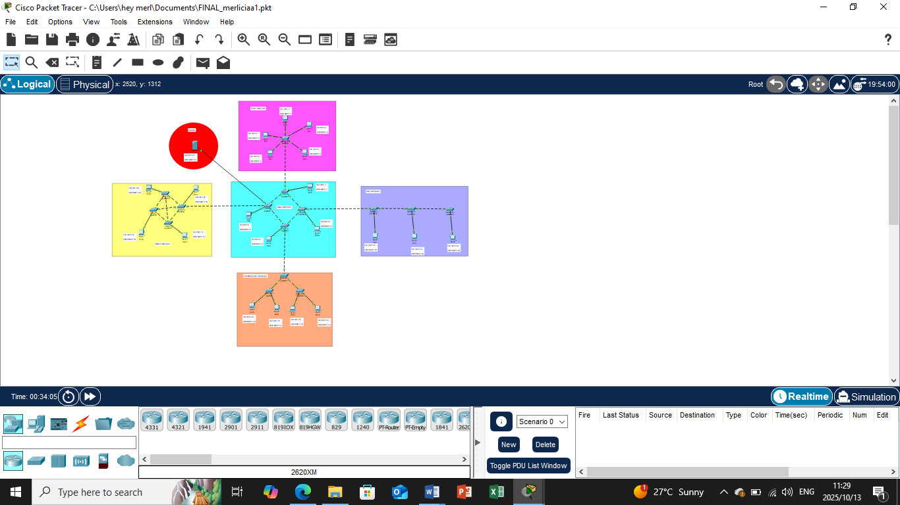

PING RESULTS
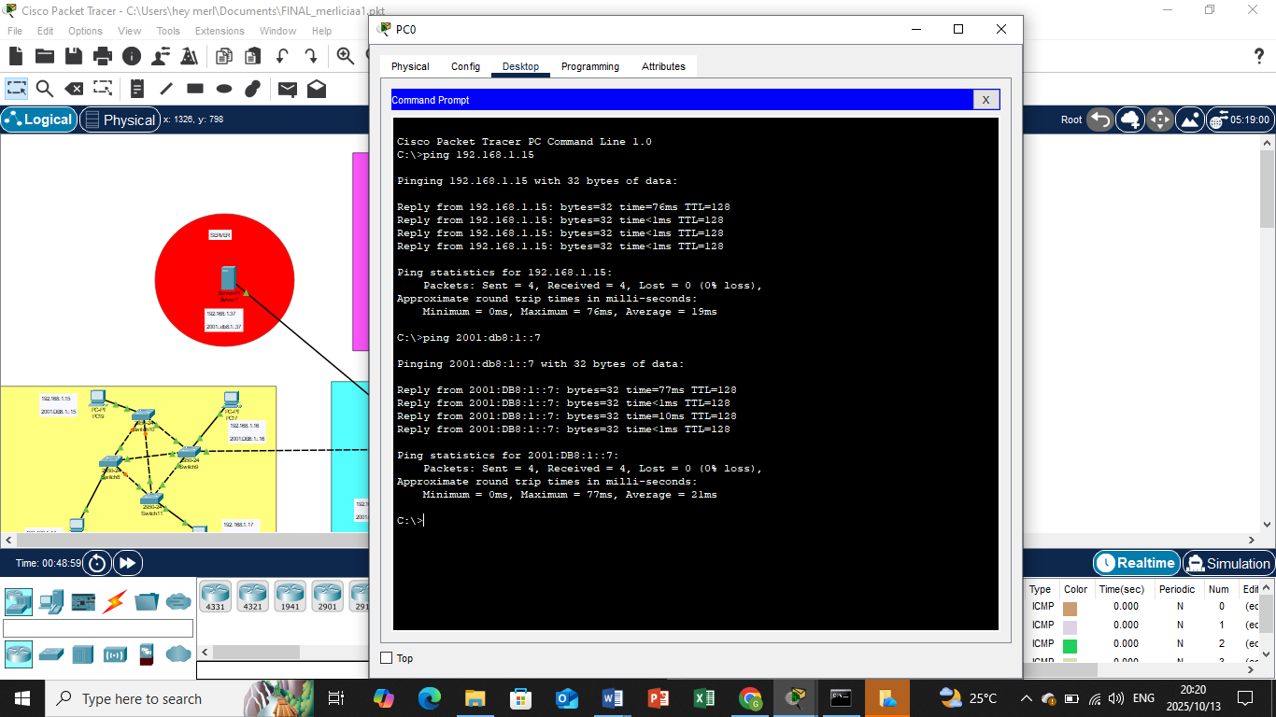

SERVER TESTING

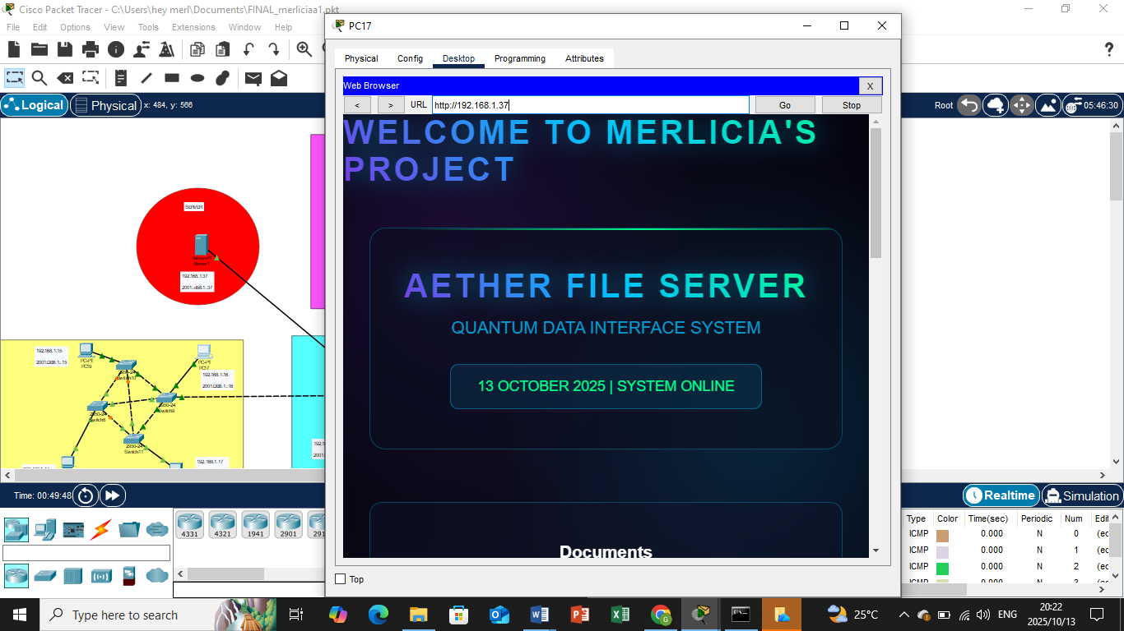

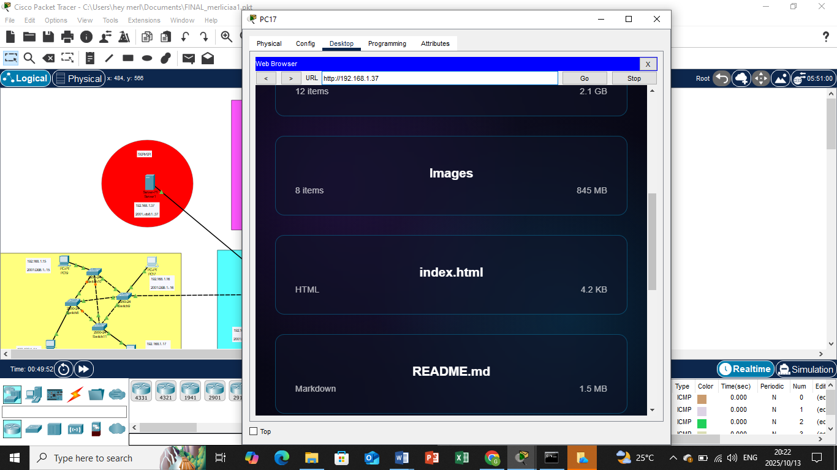

PART 2: EIGRP IPV4 CONFIGURATION SCREENSHORTS

